Banking Transaction Analysis Dashboard
Screenshot 1:
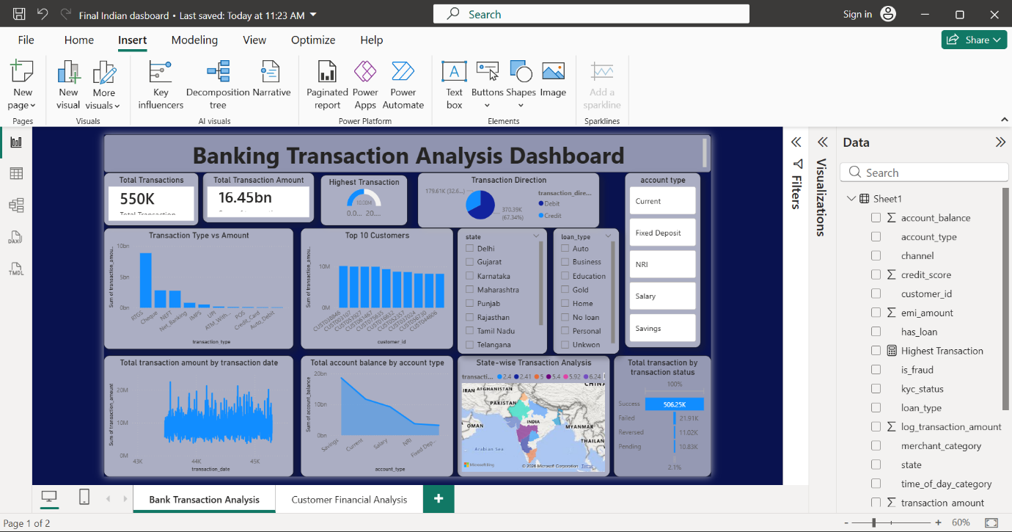
The Banking Transaction Analysis Dashboard helps analyze customer transactions and banking activities in a simple visual format
KPI Cards
- Total Transactions shows the total number of transactions.
- Total Transaction Amount shows the total money transferred.
- Highest Transaction shows the maximum transaction amount.
Transaction Direction Pie Chart
This chart compares Debit and Credit transactions.
It shows that debit transactions are higher than credit transactions
Transaction Type vs Amount
This bar chart shows different transaction types like RTGS, NEFT, UPI, and Cheque.
RTGS transactions have the highest transaction amount.
Top 10 Customers
This chart shows customers with the highest transaction amounts.
These customers are important for the business.

Transaction Trend Chart
This line chart shows how transaction amounts change over time.
It helps identify busy transaction periods.
State-wise Transaction Analysis
This map shows transaction activity across different states.
Some states have higher banking activity than others.
Transaction Status Analysis
This chart shows successful, failed, pending, and reversed transactions.
Most transactions are successful.
Filters (Slicers)
The dashboard includes filters for:
- State
- Loan Type
- Account Type
These filters help users analyse data easily.
Final Story
The dashboard converts raw banking data into simple business insights.
It helps understand customer behaviour, monitor transactions, identify top customers, and support better business decisions.
Screenshot 2:
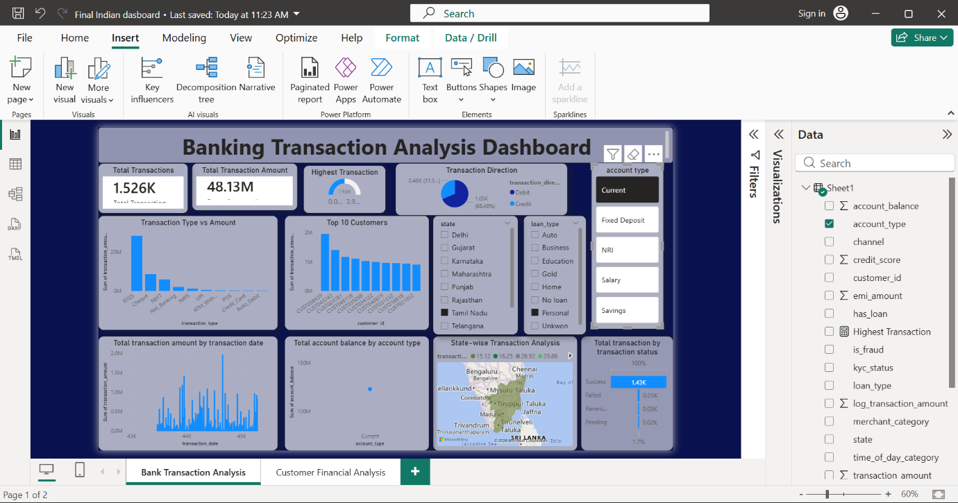
Selecting “True” in the has_loan slicer displays only customers who have taken loans, helping analyze their financial behaviour, account balance, and transaction activity.
Screenshot 3:
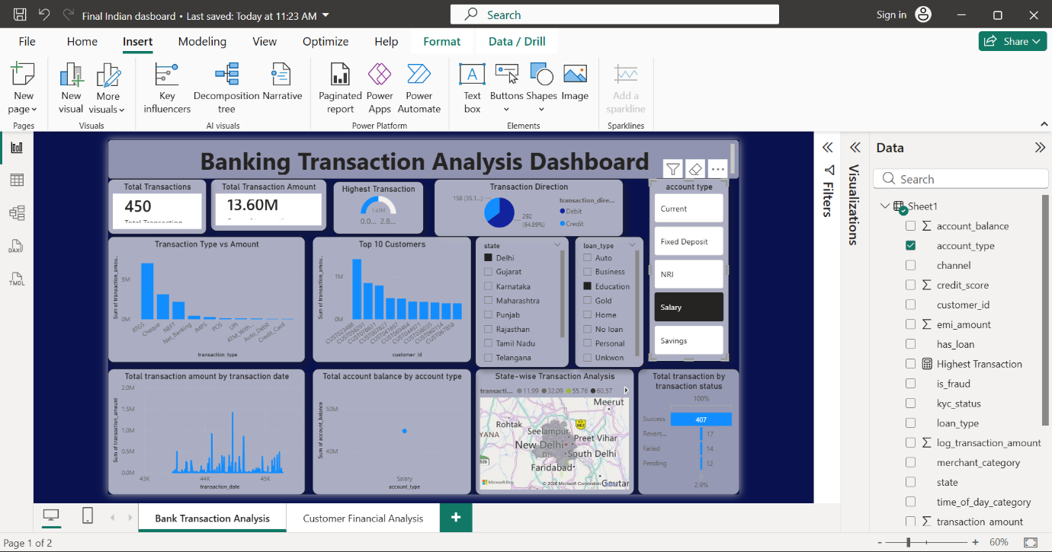
The Customer Financial Behavior Dashboard analyzes customer account balance, credit score, transaction amount, loan status, and account type to understand customer financial activity and banking behavior.

